AFGC-ACI-fib-RILEM International SYMPOSIUM UHPFRC 2017
First A. Author (1), Second B. Coauthor (2) and Third C. Coauthor (2)
(1) ACBM Center, Northwestern University, USA
(2) UPE-Ifsttar, Paris, France

Abstract
The abstract should be less than 12 lines (about 160 words).
This document provides information and instructions for preparing a paper to be included in the Proceedings of the UHPFRC 2017 Symposium (RILEM Proceedings PRO 106). The paper has to be saved as .doc file. Papers will appear in print exactly as they have been prepared by the author. Therefore, it is essential that the paper be accurately and attractively presented.
Please provide a separate page for the title of the paper, the authors, affiliation, keywords and authors’ contacts. This page will not be reproduced in the proceedings of the Conference. On this page, the name of the contact author who will present the paper will be underlined.
The paper itself begins at the top of the present page (which is numbered as Page one). All the instructions are given in the present file.
The paper should be written following the format of Word template for submission that can be found in that address. The organizers do not commit themselves to include in the Proceedings any paper received later than the above-mentioned deadline.

Résumé
The abstract in French language starts here. French-speaking authors are kindly requested to provide it. For non French-speaking authors the scientific committee will translate the English abstract. In this case please keep space of 12 blank lines.

1. Introduction
Authors should submit the paper electronically both in Word and in pdf file, to the Symposium Secretariat either through the symposium website www.afgc.asso.fr/UHPFRC2017 or at both e-mail addresses: francois.toutlemonde@ifsttar.fr and afgc@enpc.fr before January 31st, 2017. The Paper should be written following the format of Word macros for submission that can be found in that address. The organizers do not commit themselves to include in the Proceedings any paper received later than the above-mentioned deadline.

2. General specifications
The paper must be written in English. All text including tables and graphics must fit into a printing box of 16 cm x 22.5 cm on a A4 type paper, 2.5 cm left margin and 3.6 cm top margin (right and bottom margins adjusted for A4 paper), Times New Roman font (also for font used in Excel charts, diagrams or figures). No part of the paper to be reproduced should appear out of the printing box. The final pages of the proceedings will be reproduced at a factor size of 0.8, thus resulting in a final printing area of 12.8 cm x 18.0 cm. The authors should pay attention to the thickness of lines in graphics, which should not be less than 0.15 mm at the final size of the paper, for being visible in the final pdf file, used for printing the proceedings. The paper including figures, tables and references must have a minimum length of 6 pages and must not exceed 10 pages. A length of 8 pages is recommended.

3. Title, authors, affiliation
The page one of the paper starts with the title of the paper, the authors, affiliation, the Abstract. The first line of the title is located 2 cm (60 points) from the top of the printing box.

3.1 Title
The title should be written left aligned, in 14 pt, boldface Times (New) Roman, all capital letters. It should be single spaced if the title is more than one line long.

3.2 Author (s)
The author's name should include first name, middle initial if any, and surname. It should be written left aligned, in 12 pt boldface Times (New) Roman, 12 pt below the title.

3.3 Affiliation
Author's affiliation should be written left aligned, in 12 pt Times (New) Roman, 12 pt below the list of authors. A 12 pt space should separate two different affiliations. Neither full postal address nor e-mail address is to be included.

3.4 Abstract
Use 12 pt Times (New) Roman for the abstract. The word Abstract must be set in Times (New) Roman 12 boldface, not italicized. The abstract text should be justified and separated 12 pt from the keywords, as shown in the previous page of these instructions. The abstract should not exceed 12 lines.

3.5 Résumé
French-speaking authors are kindly requested to provide a French version of the abstract. For non French-speaking authors the scientific committee will translate the English abstract. In this case please keep space of 12 blank lines. Use 12 pt Times (New) Roman for the text. The word Résumé must be set in Times (New) Roman 12 boldface, not italicized. The text should be justified, as shown in the previous page of these instructions. The abstract should not exceed 10 lines.

4. Headings

4.1 Main headings
The main headings should be written left aligned, in 12 pt, boldface in capital. There should be a 12 pt space before and 6pt after the main headings.

4.2 Secondary headings
Secondary headings should be written left aligned, 12 pt, boldface Times (New) Roman, with an initial capital for first word only. There should be a 12 pt space before and 0 pt after the secondary headings. Further headings should not be used.

5. Text
The normal text should be written single-spaced, justified, using 12 pt Times (New) Roman in one column. The first line of each paragraph must be indented 0.5 cm. There is not inter-paragraph spacing.

6. Page numbers
It is requested to number the pages from 1 to maximum 10. Write the page number centred at the bottom of each page, with 12 pt Times (New) Roman.

7. Tables
Keep tables simple. Range tables and table headings left. Do not spread tables out across the page. Type the table number and title immediately above the table. All tables should be numbered consecutively and captioned; the caption should be 12 pt Times (New) Roman, upper and lower case letters.

Table 1: Example of construction of a table
C11 | C12 | C13
C21 | C22 | C23
C31 | C32 | C33
C41 | C42 | C43
C51 | C52 | C53

A 6 pt space should separate the table from the caption, and a 12 pt space should separate the table from the surrounding text.

8. Equations and units
A displayed equation is numbered, using Arabic numbers in parentheses. It should be left aligned, leaving a 6 pt space above and below to separate it from the surrounding text. Number each equation between parentheses on the far right margin. Use SI units. Use correct abbreviations for units ("%" and not "percent").
The following example is a single line equation:
Ax = b | (1)
The next example is a multi-line equation:
Ax = b | (2)
A₂x = b₂

9. Figures and photographs
If the author includes a photograph, figure or extract which has been published previously, the author must obtain written approval from the original publisher for it to be reprinted, and provide the corresponding references.
All illustrations should be placed in the text near where they are first mentioned. All figures should be numbered consecutively and captioned. The caption title should be written centred, in 12 pt Times (New) Roman, with upper and lower case letters. Thickness of lines in diagrams: A MINIMUM OF 0.2 mm IS IMPERATIVE FOR ANY LINE OR AXIS (lines with lower values will not appear in the printed book).
Layout of the figures should preferably take the full width of the page. If appropriate 2 consecutive figures can be placed close together on the same line.

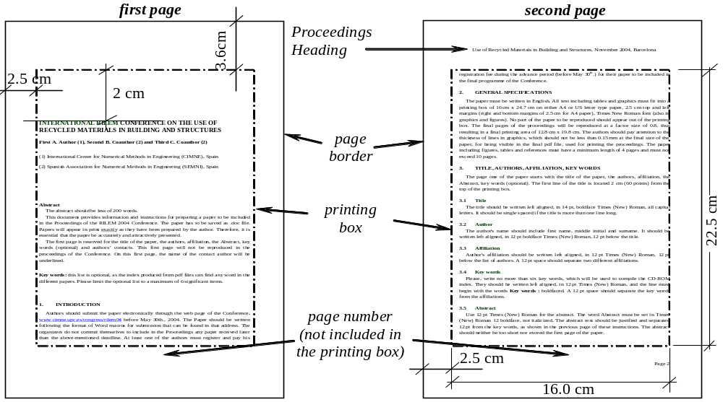
Figure 1: Page layout
A 6 pt space should separate the figure from the caption, and a 12 pt space should separate the upper part of the figure and the bottom of the caption from the surrounding text.

10. Footnotes
Avoid footnotes if possible. If you must sparingly use them, please be sure that they are typed within the margins specified above.

11. Conclusions
- The final Paper should be submitted electronically, both as Word (.doc) and .pdf files, to the Symposium Secretariat either through the symposium website www.afgc.asso.fr/UHPFRC2017 or at both e-mail addresses: francois.toutlemonde@ifsttar.fr and afgc@enpc.fr
- The Paper should be written following the present format (Word template).
- Deadline for the submission of the paper is January 31st, 2017.
- The organizers do not commit themselves to include in the Proceedings any paper received later than the above-mentioned deadline
- When sending your final paper to the Scientific Editors, be sure that you have sent back to RILEM Publications (see address below) the Licence to Publish (available on the Web site) duly filled with your handwritten signature (available on the site). Your paper cannot be published in the absence of this document.

RILEM Publications SARL - c/o Mrs Pascale DUCORNET or Ms. Anne GRIFFOIN
4 avenue du Recteur Poincaré - 75016 Paris - FRANCE
Tel : + 33 1 42 24 64 46
Fax : +33 9 70 29 51 20
E-mail : sg@rilem.org
http://www.rilem.net

- Please also provide by e-mail a scanned copy of this document and of your paper to the UHPFRC 2017 Symposium Secretariat

AFGC - UHPFRC 2017 Symposium - c/o Mrs Nadget BERRAHOU-DAOUD
15, rue de la Fontaine au Roi - F-75127 Paris Cedex 11 - FRANCE
Tel: +33 1 44 58 24 70
Fax: + 33 1 44 58 24 79
E-mail: afgc@enpc.fr
http://www.afgc.asso.fr/UHPFRC2017

ACKNowledgements
This optional heading should be inserted just before the References heading, both headings (Acknowledgements and References) being in bold Times (New) Roman 12 pt, without numbering.

References
- List and number all bibliographical references at the end of the paper under the major heading References. Number the references in order of appearance, using Times New Roman 11 pt. Authors are cautioned to give complete information about books and authors and to check spelling and dates carefully. The presentation of references is given below. Commercial papers or documents not available to the public cannot be referenced.
- Sterman, S. and Marsden, J.G., 'Silane coupling agents', Ind. Engng. Chem. 58 (3) (1966) 33-77.
- Alexander, K.M., Wardlow, J. and Gilbert, D., 'Aggregate-cement bond, cement paste strength and the strength of concrete', in 'The Structure of Concrete', Proceedings of an International Conference, London, September, 1965 (Cement and Concrete Association, London, 1968) 59-81.
- Crank, J., 'The Mathematics of Diffusion', 2nd Edn (Clarendon, Oxford, 1975).

Important note: Any paper received without the original licence duly completed (with handwritten signature) cannot be included in the proceedings.

